### **Task: Configuring and Maintaining Antivirus Software**

#### **Instructions:**

##### **1. Verifying Installed Antivirus Software:**

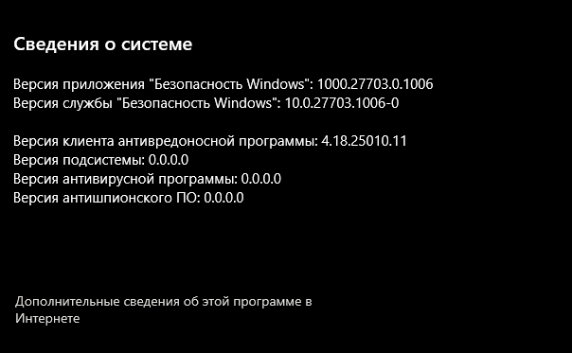

##### **2. Configuring Security Settings and Scan Schedules:**

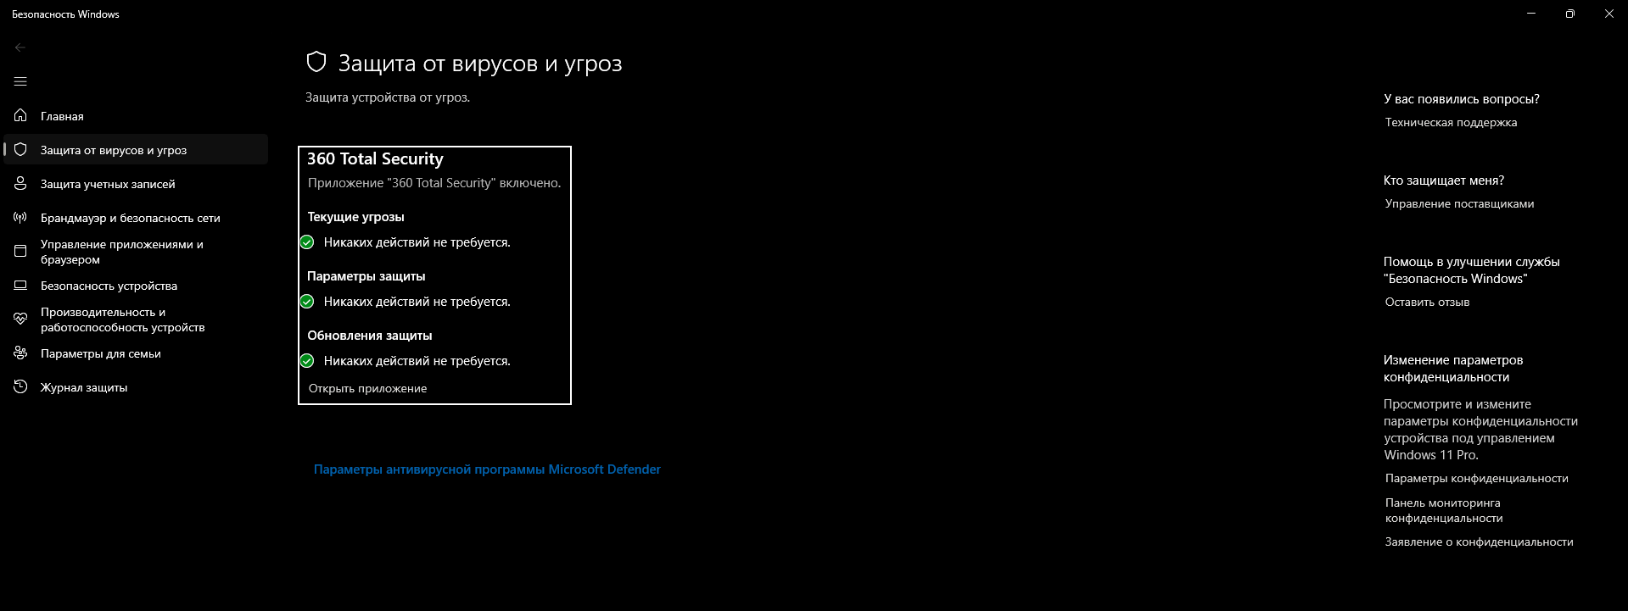

##### **4. Preparing a Report:**

The installed antivirus software, [Security windows], was verified and its version, [1000.27703.0.1006], confirmed as functional.

Security settings were configured, enabling real-time protection, adjusting sensitivity levels, and activating threat notifications.

Scheduled offline scans were set for critical areas to run at regular intervals.

An offline full system scan identified threats, which were successfully removed or quarantined.

Minor configuration issues arose but were promptly resolved, ensuring smooth operation.